
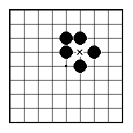
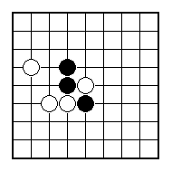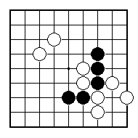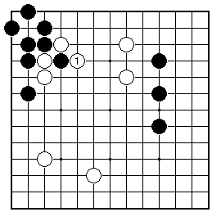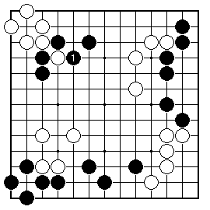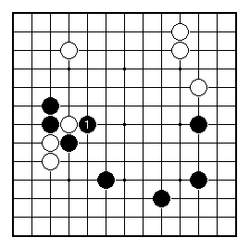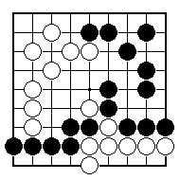
How can Black win one white stone?

How can Black win two white stones?

Does the ladder work for White?

How can Black win a white stone?

Does the ladder work for Black?

Does the ladder work for Black?

NAME:
BRITISH GO ASSOCIATION CERTIFICATE LEVEL 2 - SHEET 7

LADDERS AND NETS

